### Lab 2

Name: Eduardo Wang Zheng

E-mail: eduardo@sjtu.edu.cn

1. Requirements
2. Draw **Bezier curve**. Use the mouse to click four points in the scene to generate the relevant **Bezier curve** and drag the control nodes to see what would happen.
3. Use **Unity Shader** to realize **texture mapping** of **Blinn Phong** illumination model
4. Use **Unity Shader** to realize **Bump Mapping**
5. Experiments
   1. Draw Bezier curve
      1. Difficult points and solutions

1. Definition of endpoints and control points

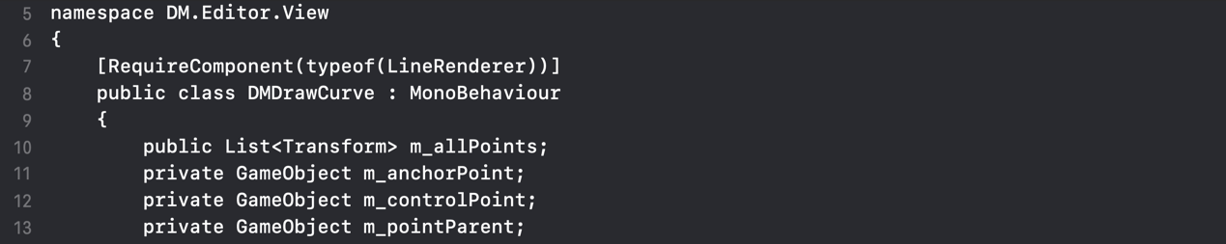

DrawCurve.cs

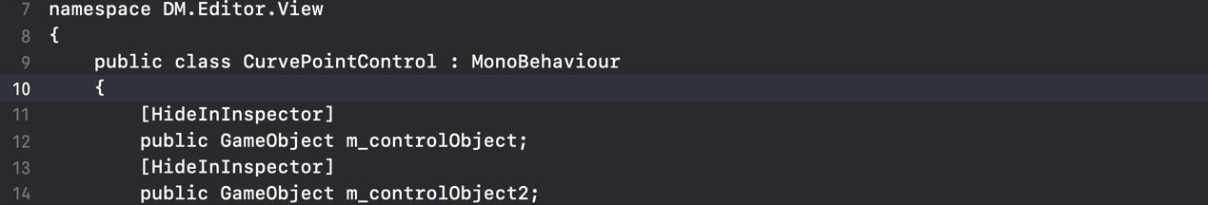

CurvePointControl.cs

2. Realization of basic operations.

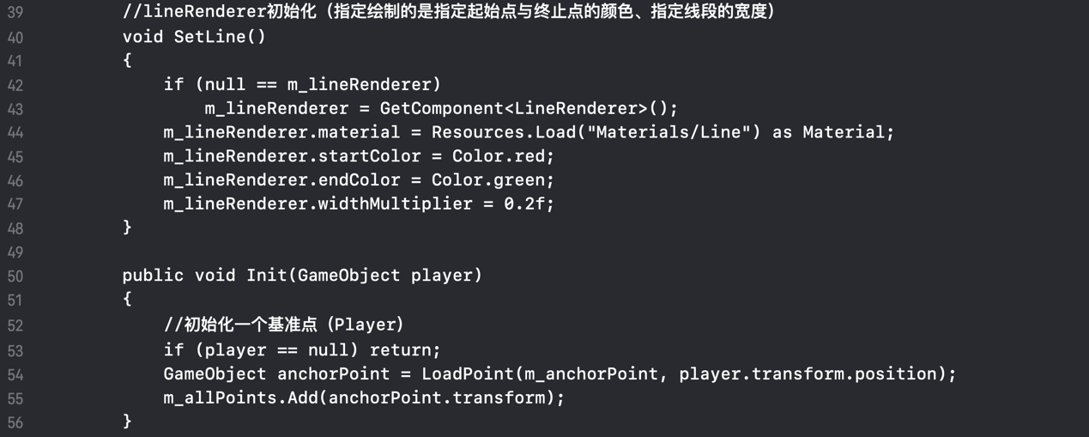

Initialization

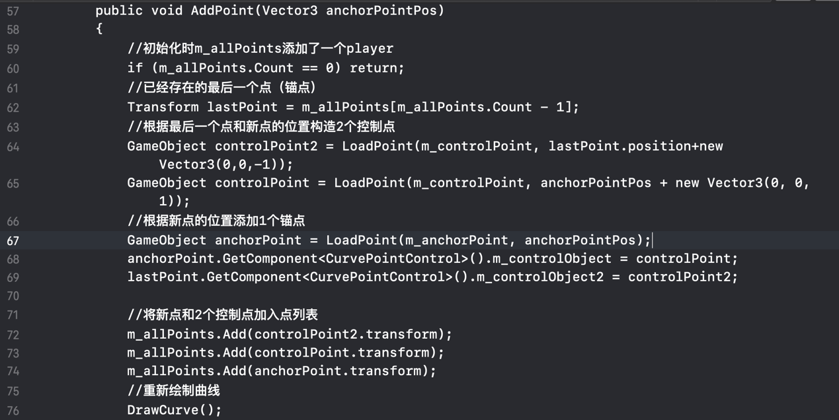

Add point (Related to mouse event)

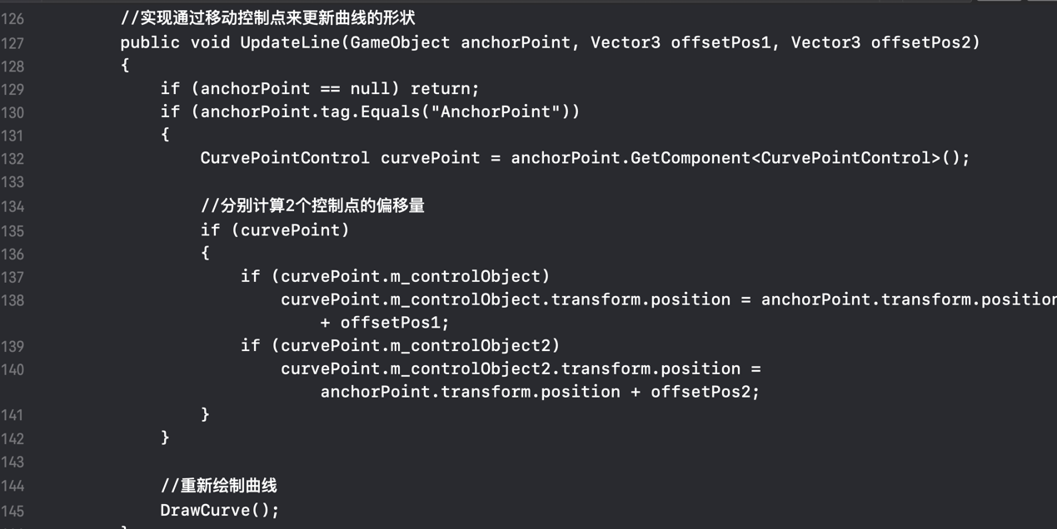

The shape of curve can be updated by moving control points

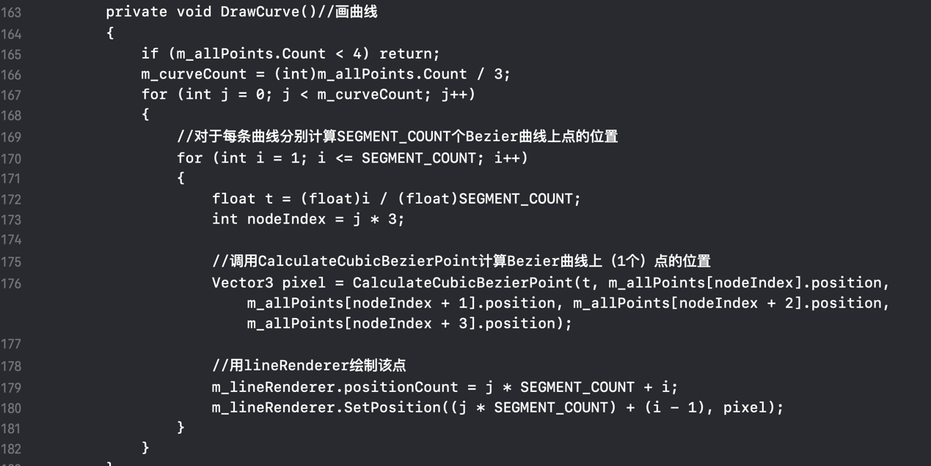

Draw curve

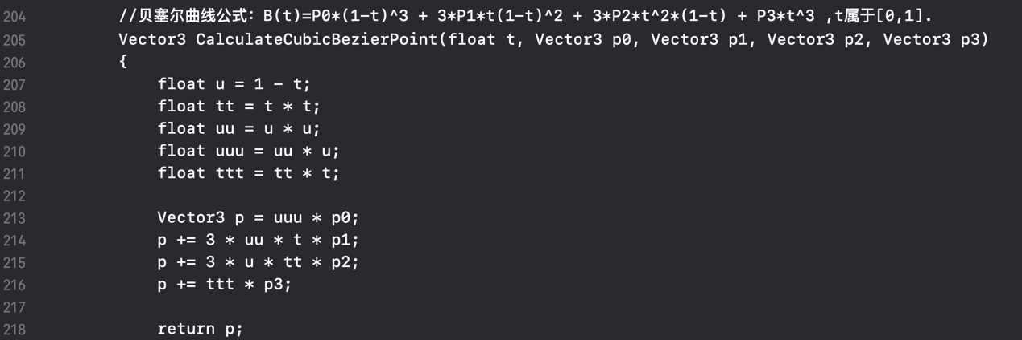

Calculate cubic Bezier point

3. Dealing with mouse events. As each segment is defined by its two endpoints and two control points and a control point determines the tangent at the corresponding endpoint, we need to redraw the curve when we drag the endpoints and the control points.

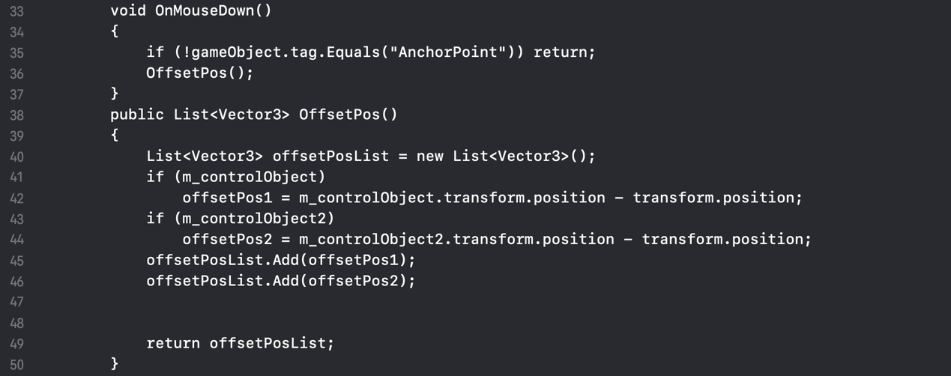

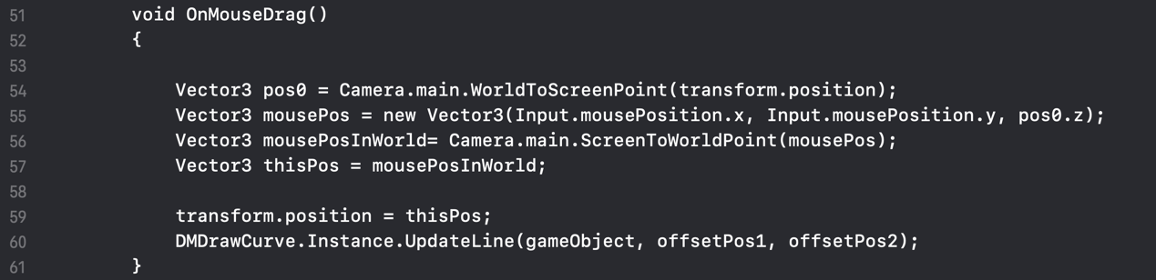

* + 1. Evaluation

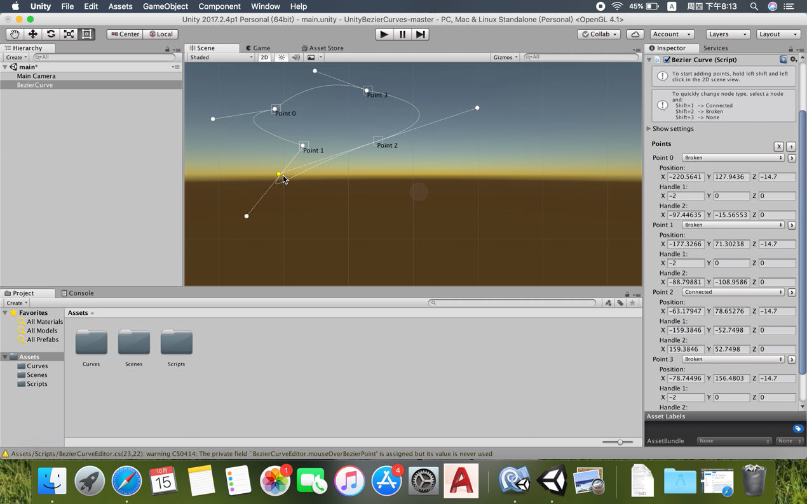

* 1. Realize texture mapping of Blinn Phong illumination model
     1. Difficult points and solutions

1. Realize texture mapping

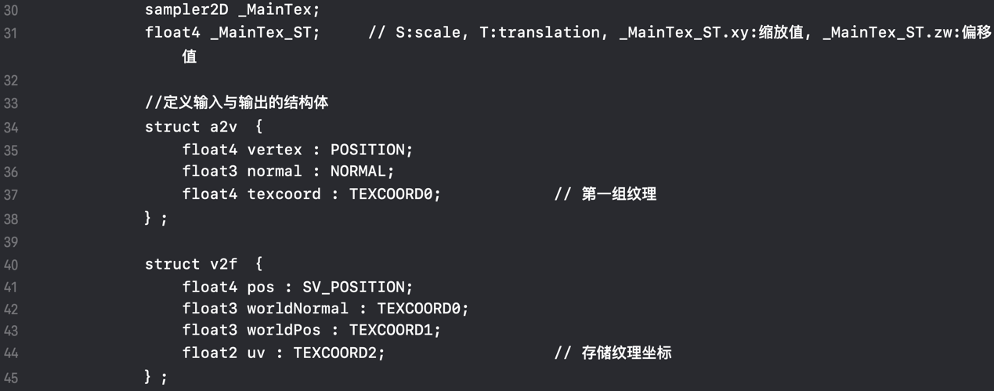

Define properties and data structures



Texture transformation

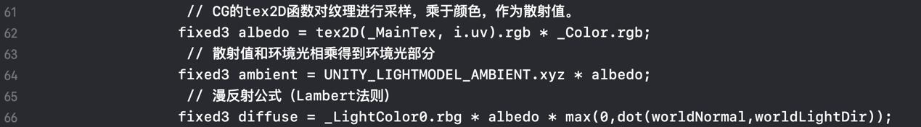

Use texture information to compute ambient light and diffuse light

2. Realize **Blinn Phong illumination model**

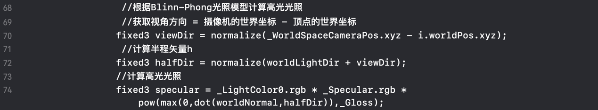

* + 1. Evaluation

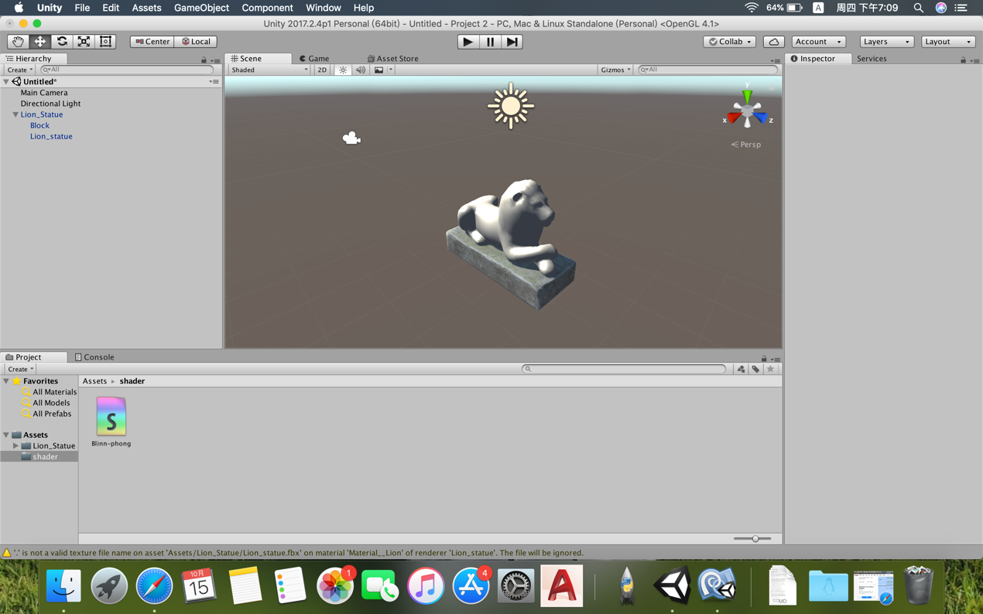

* 1. Realize Bump Mapping
     1. Difficult points and solutions

1. Define properties and data structures

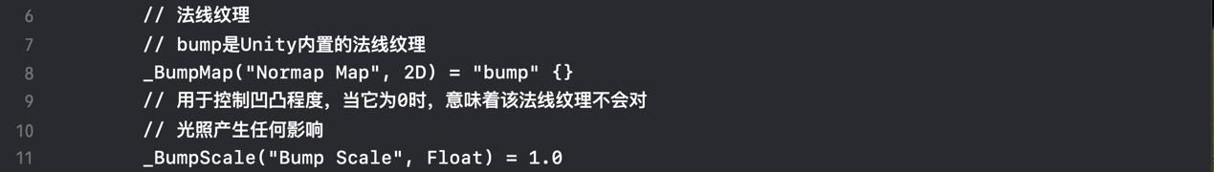

2. Transform the light direction from object space to tangent space

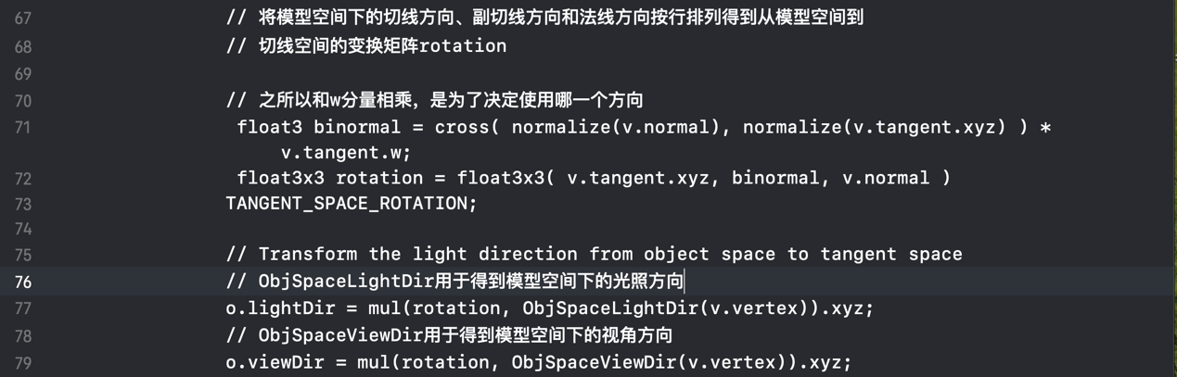

3. Store texture coordinates on different components of vertex UV coordinates space



4. Realize texture mapping and normal mapping at the same time (in fragment shader)





5. The normal in tangent space is obtained by sampling. Then illumination calculation is carried out in tangent space.

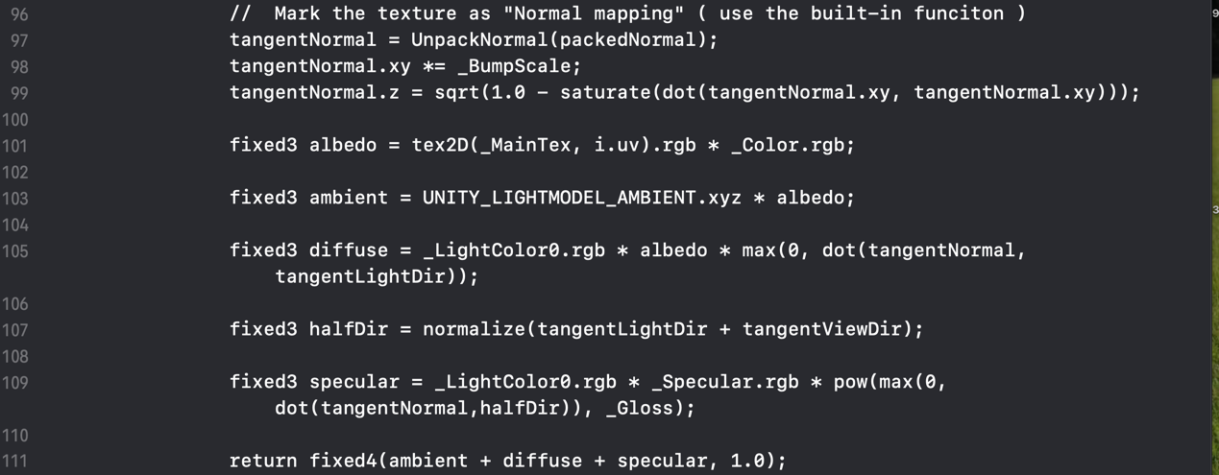

* + 1. Evaluation

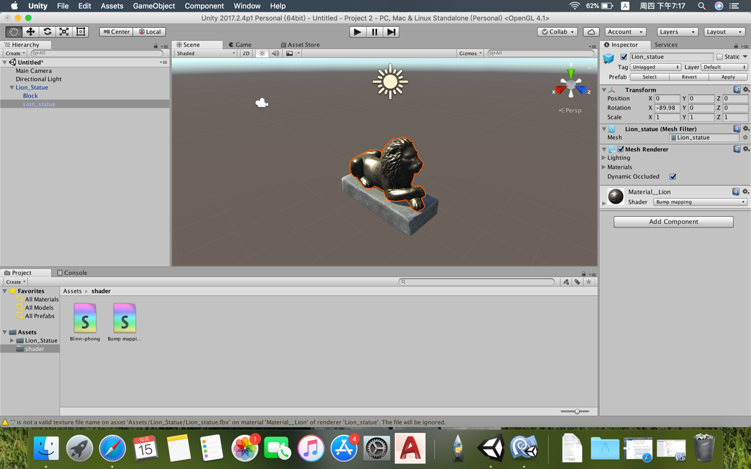

1. Achievements
2. Learn to master Bezier curve
3. Learn how to edit **Unity Shader** to realize special rendering effects (texture mapping, bump mapping and **Blinn Phong illumination model)**
4. Learn how to deal with mouse events
5. Learn how to use line render